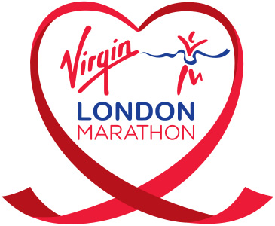
May
Newsletter

Well done to the
Virgin London Marathon ladies!
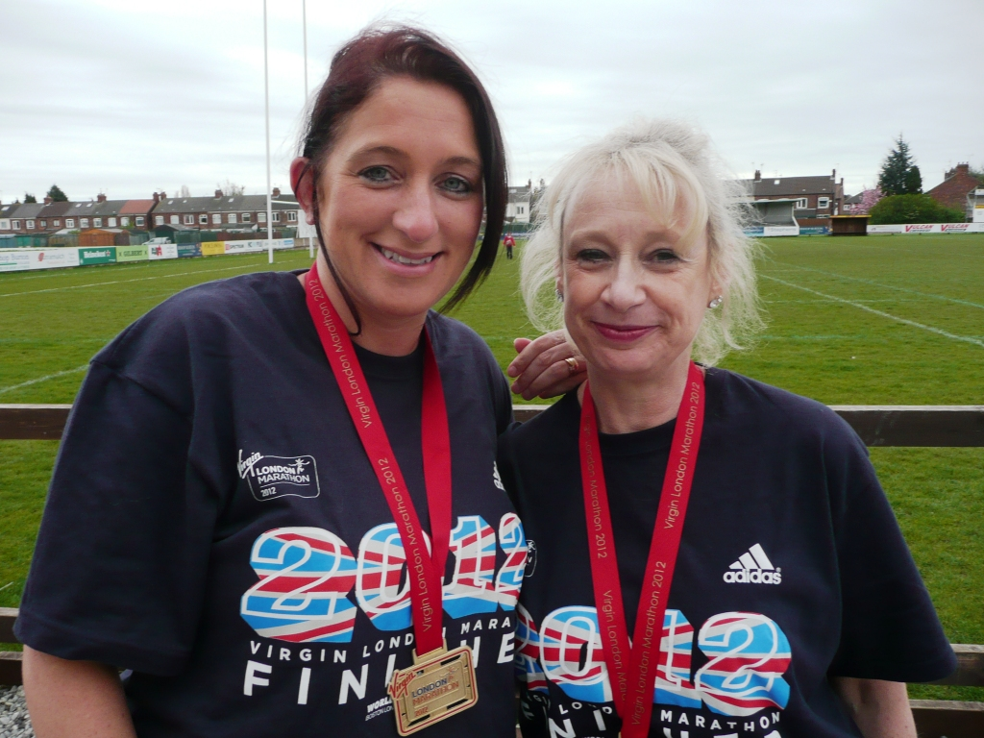

Sandra, Gill, Sharon and Antonia

WEST HULL LADIES RRC
COMMITTEE MEETING

West Hull Ladies Committee Meeting

Minutes Monday 30th April 2012

Attendees:- Victoria Voase, Amanda Dean, Ann Holmes, Debbie Watson, Verity Pick, Katy Snow, Rachael Laughton, Louise Ede and Jo Townsend

Apologies:- Annette Pearson

Hull Marathon

The various problems with the marathon were discussed and suggestions for improvements next year. Andy Tate at Beverley Athletics is interested in organising the event next year. It was agreed that Ann Holmes would draft a document setting out our suggestions and Jo Townsend would forward to Andy Tate with an e-mail confirming that WHL would support him organising the marathon next year.

(Here is the letter I drafted – Ann)

The experiences of ladies from our club of Hull Marathon was discussed by West Hull Ladies club committee, and we would like to share what have been identified as issues for consideration for next year’s event. We realise that some of these points have probably been raised already, but we have compiled a full list of issues in case there are some that race organisers may not have been made aware of.

- Route - 26.2 miles, please. There were difficulties with insufficient space around the pond at Pickering Park, and the path along Victoria Dock was also narrow, with little room for more runners in successive years. Also the capstan turn around point was only 3 metres from a very dangerous drop, which is a significant hazard for fatigued runners with lower levels of concentration. An alternative route has already been proposed and forwarded to you, but is included below as well.
- Signage - Mile markers are essential, as well as better signage. One volunteer in our club suggested signs be pre-punched to make it easier to fix them more securely to trees / lampposts.
- Marshals and volunteers - More were needed, with high viz vests so that runners can see them. It was also noted that marshals were not formally thanked afterwards, although we are aware that free entry was promised for 2013. The list of volunteers compiled regarding this did not include those who ran the water stations. Volunteers were also expecting T shirts. At Pickering Park some volunteers were more concerned with completing surveys than helping, so volunteers need to be clearly briefed about what the expectations are. Extra people were needed at registration, as long queues were forming and those helping out were really too young to be effective.
- Leadership – zone managers need to be in situ in good time. There is a wealth of advice on offer from those who have experience of races of this distance which would be prudent to seek and follow. Improve communications so that there is a phone number for zone managers / marshals to ring when there is a problem.
- Water stations - More were needed, with greater security so that water is not stolen, with better planning and guidance so that water is delivered to the right location. West Hull Ladies ran the first water station and found that most runners wanted bottles rather than cups, and therefore the tables were not necessary, as they were not strong enough for bottles.
- Safety – have a tail runner who can inform marshals when to pack away and make contact if there are medical emergencies. St. John’s Ambulance could have been more visible along the route – perhaps offering Vaseline in latter stages of the race. A sweep vehicle was needed to assist runners needing to withdraw to return to the city centre.
- Relay – ensure hand over points are clearly signed. Consider transporting runners to handover points, and returning to the finish. There were difficulties with timing with one team having no time at all at first, but also the final times were an hour quicker than they should have been.
- Timing – Many felt that an 8 o clock start was too early, but also that coinciding with Easter Day meant many businesses were not open, but could have benefited from extra trade for spectators, runners wishing to eat in town afterwards. This is an opportunity for Hull to really benefit commercially from the marathon.
- Pace makers – more visible, perhaps carrying a lollipop sign with the pace on for runners to look out for.
- Finish line – needed more space. Keep runners walking towards medals, food, drinks to allow heart rates to slowly return to normal. Those awarding medals could have been more enthusiastic – this is climax for those taking part!
- Fun run – publicise this more, to get more taking part, and ensure it starts on time.
- Entertainment – have someone with a bit of personality announcing runners in at the end. Boost runners with music – bands, music, drumming. There are plenty of groups in Hull that would love to have assisted with this.
- Facilities – St. Stephen’s car park was the official car park, so ensure the toilets were are open. Toilet facilities generally were insufficient – more Portaloos, please.
- Prizes – category prizes were expected but not awarded. Also not all relay runners received a medal and T shirt – so a clearer strategy for rewarding runners would be good.

We believe this could be a great event for our club and indeed for Hull as a whole, as it encompasses different race types allowing for different challenges and it would be a shame to see it not run smoothly in the future. We would be supportive of whoever organises the 2013 marathon, and would be happy to run the West Park water station again.

Ladies, did you know that ...?

1. Fast running burns more calories than slow running, but slow running burns more calories than just about any other activity. In short, nothing will help you to lose weight, and then keep it off, the way running does.
2. Doctors consider that moderate exercise during a normal pregnancy is completely safe for the baby. Running should cause no problems in the first trimester and it should be fine for most people in the second trimester. Few women would run in their final three months, however. The most important precaution is to avoid getting overheated; a core body temperature above 101°F could increase the risk of birth defects. So make sure you’re staying cool enough, and if in doubt, take your temperature after a run. If it’s over 100°F, you’re probably overdoing it. Also, skip that post-run soak in a hot bath.
3. An American study found that running women produce a less potent form of oestrogen than their sedentary counterparts. As a result, female runners cut by half their risks of developing breast and uterine cancer, and by two thirds their risk of contracting the form of diabetes that most commonly plagues women.
4. Running helps to produce healthy skin. According to dermatologists, running stimulates circulation, transports nutrients and flushes out waste products. All of this leads to a reduction in subcutaneous fat, making skin clearer and facial features more distinct.
5. No matter what your size, it’s a good idea to wear a sports bra when you run. By controlling breast motion, it will make you feel more comfortable. Look for one that stretches horizontally but not vertically. Most importantly, try before you buy. A sports bra should fit snugly, yet not feel too constrictive. Run or jump on the spot to see if it gives you the support you need.
6. If you ran early in your pregnancy, you might want to try switching to a lower-impact exercise during the latter stages and after delivery. Because of the release of the hormone relaxin during pregnancy, some ligaments and tendons might soften. This will make you more vulnerable to injury, especially around your pelvis. Walking, swimming, stationary cycling and aquarunning (you’ll be even more buoyant than usual) are good choices.
7. Trying to lose fat by eating less and less and running more and more doesn’t work. The more you exercise and the less you eat, the more likely your body is to ‘hibernate’. That is, you’ll conserve calories and thwart your efforts to lose fat. The better bet is to exercise reasonably and increase your food intake early in the day to fuel your training. Eat breakfast, lunch and an afternoon snack. Then eat lightly at dinner and afterwards.
8. ‘That time of the month’ (or even the few days preceding it) is not the time when women run their worst. The hardest time for women to run fast is about a week before menstruation begins (a week after ovulation). That’s when levels of the key hormone progesterone peak, inducing a much-higher-than-normal breathing rate during exercise. The excess ventilation tends to make running feel more difficult.
9. Just because you’re married and have young children and a job doesn’t mean you don’t have time to run. Running is time-efficient and the best stress-reducer on the market. You need this time.
10. Babies dislike the taste of post- exercise breast milk, which is high in lactic acid and imparts a sour flavour. One study found that nursing mums who logged 35 minutes on the treadmill had to cope with grimacing, reluctant infants if they nursed too soon afterwards. Researchers recommend that you either collect milk for later feeding, or breast-feed before running.
11. Women sweat less than men. However, contrary to popular belief, women dissipate heat as well as men. The reason: women are smaller and have a higher body-surface-to-volume ratio, which means that although their evaporative cooling is less efficient, they need less of it to achieve the same result. Nonetheless, be sure to drink plenty of water (until your urine runs clear) to offset the effects of sweating and prevent dehydration.
12. While no one has ever proved the old theory that women are better marathoners than men (because they have more body fat to burn), you never hear anyone argue the opposite. Men tend to use their strength to push ahead in short races, but this can backfire in a marathon. Women seem perfectly content to find a comfort zone and stay there. This makes them ideally suited for the marathon – the ultimate keep-your-cool and keep-your-pace distance.

So why not be bold and set your sights on a marathon?

Virgin London Marathon

Sandra

I am not quite sure where to start as I seem to have been on quite a journey getting to this stage of having actually completed the London Marathon. Maybe it is a little too soon to be writing this as I still feel quite emotional about having done it – but then again maybe now is the right time as it written from the true memory and not how I thought it was.

Way back in 1990 when I was a young slip of a girl I ran the London Marathon with my Dad. After about 6 miles I ended up running on my own as Dad was injured. My goal was to do under 4 hours which I just managed by a mere 15 seconds– no chip timing in those days so ignore the main clock! I can say that I did not recall seeing any of the sights and just found it a really hard slog – I vowed never to do it again….and then I joined West Hull Ladies!

I saw other club members running Marathons and together with the fact that it would be the Olympic year I did the easy part and filled in the entry form. The letter then came through that I had been successful. I was euphoric and then it dawned on me what I had to do!

Whilst the proper training didn’t start until after New Year because of running both the Great North Run and Rudolph Romp I had some good long runs in my legs – I then had a brilliant run of 8 weeks fantastic training – starting just after Christmas – but come the middle of February it all started to fall apart when I suffered an ankle injury. I was never diagnosed properly due to the swelling but I think it was due to over enthusiasm running in the snow and maybe overdoing my mileage – lesson – stick to the plan – never go over the mileage or you are asking for problems.

I wasn’t able to start running again until the first week of March and then I ran the East Hull 20. In some ways this was a mistake as I got injured again but in another it gave me confidence that I could run the 26.2 miles. My injury this time was diagnosed as a groin strain but I had pain all down my right leg. So that was the end of my running again until I went to Germany at Easter to stay at my brothers. Whilst there I tentatively went running starting off with 2 x1 miles – I was by the end of the week able to increase it to 5 but was still in pain.

Whilst I was away several ladies were running the Hull Marathon and then Ann did the Brighton.
Jealousy is an awful emotion but I was so jealous of you ladies – doing so well and accomplishing so much – I just wanted to be up there with you.

I can’t believe I felt like that – the girl who in 1990 said ‘never again’.

But decisions had to be made – should I - could I run it? I had the option of deferring until next year but I didn’t want to do that – I knew I wouldn’t do that – I didn’t think I could motivate myself to do all the training again with the possibility my legs would again fail me. Anyway the Saturday before I made the decision I was going to run it. Once the decision was made I felt quite confident – even if I had to run/walk I would do it – and I could always drop out if the worst came to the worst.

So…. Last Saturday I travelled down with my husband and 2 daughters to London – collected my number- went to the hotel and then went off to see how to get to Blackheath. The journey took about an hour and involved 3 changes and some walks – I wasn’t impressed really – not wanting to do it myself the next morning. I also thought I would be tired before the gun even went off.

The Sunday arrived and what a beautiful morning – I managed my porridge and coffee and then set off. The journey was good – very quiet- I think most of the other runners were making their way to a main line station whilst I used the DLR and underground.

I couldn’t believe the organisation of the event. Once at Blackheath I was able to get a cup of coffee – sit on my bin liner and relax. Didn’t have queues for the toilet – everything was just so calm I couldn’t believe it.

I ran from the blue start and was in pen 8 of 9. I was a bit worried about this as I had a train to catch at 5.15pm and if my leg really started to rebel I could be in trouble (especially from hubby and daughters).

No need for worries though – the start was good ( 10 mins) – save for the fact I had thought of running with the Runners World 10 minute mile pace group. The leader for this was in pen 7 just ahead of me… but they separated the groups by a minute or so and I never saw the group again until about mile 19 when they overtook me and I couldn’t stay with them.

Well we set off and I felt quite good – looked at my Garmin and saw I was running 9 minute miles but it felt quite slow and I felt ok – stopped for a toilet break at the 600 metres and then I was off.
This run was so much better than 1990. I never appreciated the crowds before – there was just so many of them every step of the way apart from one stretch of about 100m near the end where there was some hoarding up. The peace actually then was quite nice – you didn’t realise how noisy it was!

So things were going well –I got quite emotional when we reached the Cutty Sark – it looked fantastic and to me it epitomises the London Marathon.

I felt fine up until about mile 10 then I could feel the pain in my legs but surprisingly it was my left that was the more painful. Probably I was using it to support my right.

I reached the half marathon in 2hr 10 so was well pleased. I then felt that things were starting to get worse. I wasn’t sure where my 3 supporters were and I felt that I was just so tired and struggling and I really wanted the boost of having a hug with my daughters – oh and hubby as well!

Maybe that kept me going because I was just thinking where are they? And then there they where – mile 19 or 21 – I heard them shouting me so went back and had my much needed cuddle – it felt good.

So off I went again – all the way round I just drank in the atmosphere – unbelievable – made me proud to be British – if I tried to walk the crowd wouldn’t let me! As others have said having your name on your shirt makes so much difference – the encouragement the crowd give is unbelievable.
Once I reached 20 miles I was scared about what was going to happen – could I make it without bouncing off that dreaded wall – but I had been taking on plenty of fluids and gels – and guess what - I DID IT – and although I was in desperate pain (I have to say I did take painkillers before and during and carried not only fuel gels in my waist pack but also my Ibuprofen gel), for a lot of it I loved it…..
As I was running I just kept telling myself to lift my body up and look around me – all different strategies come into the head – count to a 100 – only 7 miles to go – that’s just round Green Lane – a mile to go – that’s to West Bulls ……..

When I read the other reports from the West Hull Marathon Ladies I realised how lucky I was to do the London and how much easier it was – the organisation was incredible – drink stations every mile – Lucozade fuel stations (not sure how many of these there were but seemed to be a lot ) – delivered in 330ml bottles so I could carry them with me – felt like they were my lifeline and just knowing I had one made me feel better. Gel stations and wonderful support - – there was just so much going on it made 5 hours go quickly. Yes honestly!

Would I do it again – in all honesty I think I would but I won’t!

How am I now? – my legs are very sore but don’t feel like there is permanent damage – but the blisters are the worst – if you are squeamish close your eyes now !!! I think these beat Cleggs on Run Fat Boy Run.

So all you Ladies out there I can thoroughly recommend London – it was a fantastic experience.

Sandra
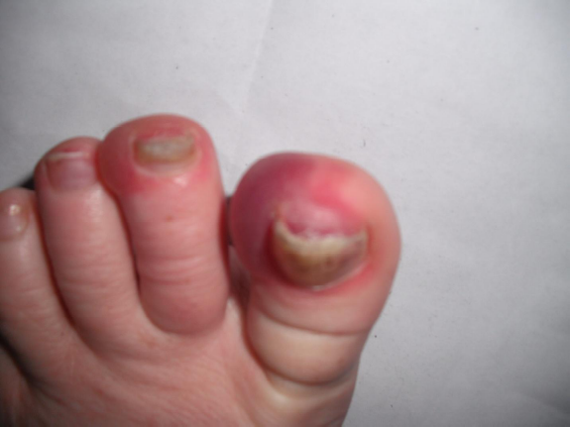
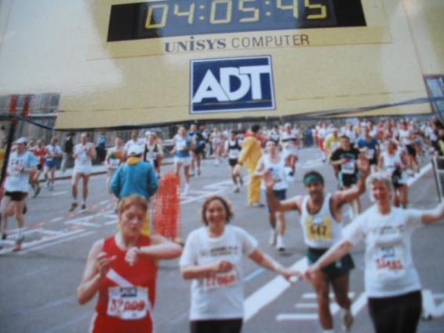

Beverley 10k

Amanda

Possibly the worst preparation for a 10K race but who would miss a couple of wonderful days at Beddgelert in North Wales?
Headed over early on Friday meeting a friend to run off road, over a large hill, down the valley and back over the hill - 12.6 miles and lots of climbing/descending. During this time, husband Neil cycled then we all went off to our hotel. Then on Saturday, the five of us scrambled (easy rock climbing) up a peak then dropped and climbed three other peaks before a massive descent to the valley which did a grand job of trashing our quads.

Beverley 10K morning, a struggle descending the stairs (ouch) and hard work going back up! I did a fair bit of jogging and active stretches at Beverley Sports centre trying to encourage movement into my legs and remove some of the stiffness. It did help.

Started close to the front but took a while before getting round the slower runners. However, I wanted to keep it steady at first so not too annoying but not good for people hoping for a PB. I enjoyed going up the hill and didn’t mind the head wind. The temperature was perfect for running. Passed a lady (Julie) in the little downhill around mid way then she pulled past again on the up. I like it when we turn at Walkington traffic lights. Not far to 4M marker and flat or downhill all the way now. So I concentrated on my form and got into a good rhythm passing Julie .... who passed me again. Kept up the pressure on myself (it is sooo easy to ease off on down hills), passed Julie, and into the market area. Urg! Humpy, wumpy, bumpy, cobbley, bobbley. Smoothed out then started to push. A lady in sight but she must having been pushing too because she didn’t get any closer. Great to get through the finish and very pleased with my time of 43:09. Much better than expected as, with the leg tiredness, I had only been aiming at sub 45mins.

Handed a bottle of water. Had a piece of orange then pineapple, then more pineapple, then more (sorry, it was sooo nice) and finally a banana. Enjoyed cheering in our ladies who seemed to either have great runs or epics. Then off for my T Shirt, shower, lunch and the presentation where I received a nice prize for 1st FV50 to spend at Simply Running.

Back down to earth with a bump as I then headed off to Tesco for the big shop.

Jill

Quite frankly I was dreading this race a bit, because I have been struggling with achillies tendon soreness, and pulled calf muscles on and off since Christmas. In fact I cried off the Brantingham champagne league run on the Tuesday before the Beverley 10k race, because I had hurt my ankle in the recce on the previous Sunday running up the dreaded Westwood hill!

Having said all of this, I had really enjoyed the 2 recces that we did because there had been so much positive cameraderie and encouragement from other WHL runners and I am so glad we did them (despite the horizontal rain) as it gave me the knowledge about where I needed to be careful to avoid antagonising my ankle, and where I could throw caution to the wind a bit!

Me and Louise W travelled together to the race on the day, which was really nice, and it was really good to see lots of people that I am starting to get to know through running...in fact it was a lovely atmosphere. It was particularly nice to see how pleased some of the kids were with their medals from the earlier fun-run.

I started the run fastened together with rock tape for my sore tendon and calf, Compeed blister plasters for my blister caused by my shoe inserts prescribed by the podiatrist to try and make me run better(?!?)...and my very fashionable white compression socks!!!

I took things quite steadily out of Beverley and up the dreaded hill and was so relieved that I got to the top and was still feeling good. It was lovely to get support on the way round from various people, and particularly Jo and Kate at the first water station. The wind was a bit rough on the way out, but luckily there was a group of large firemen running near me so I tucked in behind them as a wind break (!!!).

It was nice to get to the traffic lights at Walkington and then know that most of the course was downhill from then on. I was also pleased that I had taken advice from Louise and Amanda about just running in my running vest, beause it got really quite hot, despite the wind. Maria came past me on the run into Beverley and encouraged me on, and I think it was Sandra out on the top road who was shouting for us, which was really welcome!

The run to the finish was great because there are so many people clapping and cheering, and it was nice to meet up with quite a few of the club runners at the finish and collect our very stylish tee shirts. I was sooo pleased that I got round without hurting my ankle again, and was delighted with my time, even though I have previously run a faster time at York, because this is a much more challenging course with the hills. I just thought that it was such a well organised event and i can see now why the entries filled up so quickly.
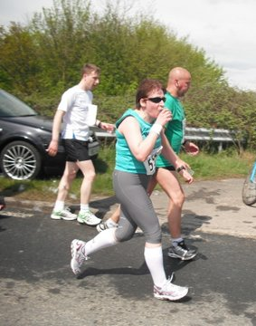
Must do it again next year!

Ann

This was my first race post Brighton Marathon (not counting the summer league 6) and I was a lot more relaxed about it than I was last year, when it was my first 10k. I didn’t have a time in mind, and was just happy to be with so many other WHL on such a sunny day.

In the buzz of the start I lost my satellite signal on my Garmin, which threw me a little, but I didn’t fret and just noted that I’d need to add a bit on to the numbers. Instead of tearing off after Rachael and Sara like I did at summer league, I hung back, and remembered to keep something back for later.

Up the hill – slower but fine. Great to see Kate, Jo and Sandra at the water station – a nice surprise. Down the hill – I said a little ‘thank you’ to myself for Amanda’s words at Humber Bridge hill training, about working hard on the downhill, and managed to over take a few people there.

Up the second hill and past half way now, still feeling strong. I enjoyed the gradient here, going back down through the Westwood. This was a good run, and I was happy with my pace. I still felt strong, and spent the last couple of miles just trying to hang on to my pace.

Heading towards Wednesday market I was thrown by an overhead banner, and mistaking this for the finish, I put in a sprint and overtook a couple of people, only to realise I still had further to go. I was barely able to breathe at that point, but figured it wouldn’t kill me, so pushed a bit more to the end.

And yes – this time I got the pineapple, they’d run out last year by the time I finished. This was a great reward for a seven minute improvement on last year’s time.

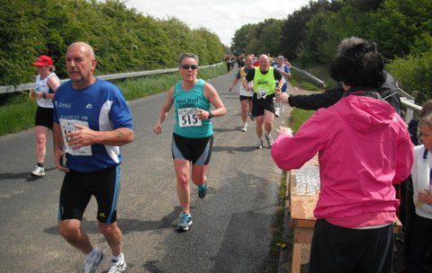
Happy days!

Sharron

Wow, that was great! As most West Hull Ladies know I "entered" last year but (ashamedly I know, telling this to a running club) I walked almost all the way.....but, this year, with joining the club, the build-up and the recce I was ready for it.

What a wonderful day, seeing everyone, the run, the support...fab - personally, I am THRILLED with my time, THRILLED, didn't think I'd get under 70 minutes.

Found it hard up the long incline to 2 miles, settled in after that, tackled the other hills as I came to them, only stopped to take in water - I haven't yet learnt to drink a cup of water whilst running.

From 5.5 miles was willing the finishing line to come round but the support got me to Saturday market where Ruth and I actually got a little faster on the run in to the finish line (I thought).

Got a little emotional finishing but I really did enjoy it! A big thank you to all the ladies with their encouragement and a special thank you to Ruth. I don't think I'd have got anywhere near this time with out Ruth running by the side of me.

Well done to all the other West Hull Ladies - saw most of them amongst the crowds at the end therefore it was great to be able to congratulate them too, thanks for staying to support Ruth and I.

Just going to get myself another glass of wine.......Sharron x

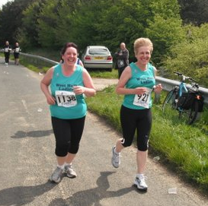
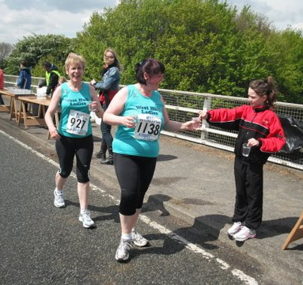

Lisa P
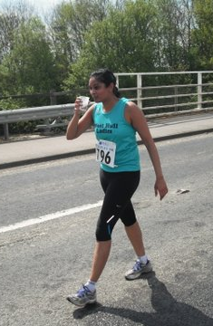
Weather wise the day of the race could not have been any different to the horizontal rain I faced during the 1st recce. Though that did mean I was too hot all the way round and did struggle in the sun, at one point I tried to run in the shadow of the man in front of me.

I was so glad when I finally saw the finish line but disappointed that I was slower than last year (by 14 seconds!). However I will probably still do this race next year even though I don’t like hills, because the support is great all the way round especially from the non running WHL and its really nice starting off in a big group of WHL even if most of them run off in the first mile.

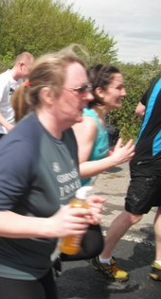
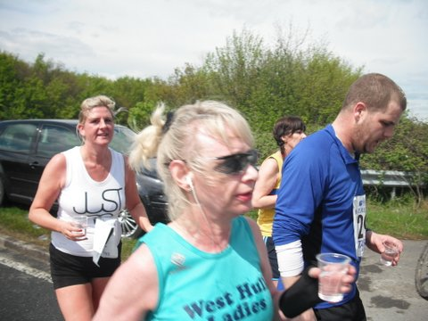
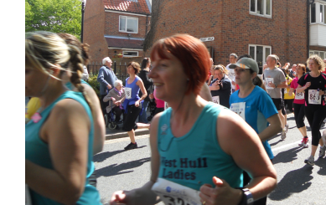
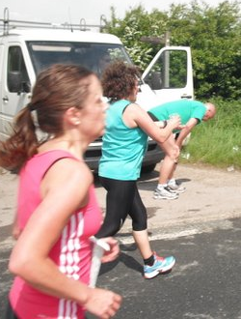
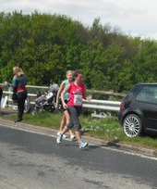
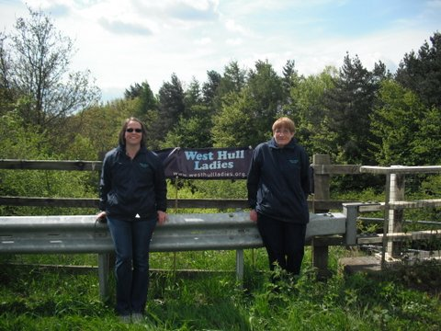

North Lincs Half

Verity

I entered the “North Lincolnshire Olympic Year Half Marathon”, not for the fancy title, but because it was advertised as fast and flat. The route did not disappoint. My aim was always to get my first sub 2 hour time and I did it – 1 hour 49 minutes 3 seconds.

Race HQ was based at Glanford Park and after signing in and picking up my number I realised the one downside to this race – no timing chips. I’m presuming that this will be rectified for next year since, judging by conversations at the start line, I was certainly not the only runner that was surprised by this. While waiting at the start I found that my Garmin was flat (which I still don’t understand since it was plugged in all night) so I was now more than a little nervous about how I was going to keep the pace I needed.

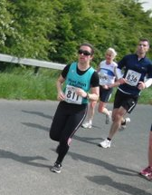
The race started at 9:01 which made it easier for me to keep track of my pace using just the time on my watch. My mind was kept constantly busy with calculating my pace at each mile marker. I knew I was doing alright when I reached 5K at just over 25 minutes. I must have missed the 10 mile marker so the 11 mile sign came as a very pleasant surprise. I ran as fast as my little legs would carry me and I was spurred on by the sight of the stadium. In the last 800m we had to go over a footbridge over the M181 and the slope up to the bridge was just about the last thing I needed but I knew I was on for a great time so I ignored the pain in my legs and kept pushing for the line. The time on the clock made it all worthwhile! After the race we were greeted with a medal, bright orange t-shirt and a goody bag with included a chocolate bar and a bag of crisps – perfect!

Given that this was the first time this race has been run in twelve years they did an excellent job. Everything that was promised was delivered: roads were closed and marshalled, there were mile markers, the route was accurate and it was a flat, fast course. As long as they use timing chips next year then I definitely recommend this race especially if you are looking for a PB.

Caption competition ...

Answers by email please ...!

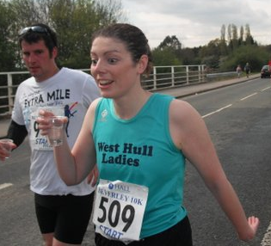

How about ...

“Vodka and tonic? Wow, the organisation on this race really is excellent”.

Or

“Bless him – he’s followed me for the past two miles offering me that drink”
Racing and Running Events

Date | Event | Distance | Fee | Entry / website
May
27th 9.00 | Sheffield Half | Half marathon | £23 | http://www.runbritain.com/
26th 10.30 | Ultra Running Made ultra simple - training | 4-5 hours | £25 | www.gobeyondultra.co.uk  training for October 6th
27th 1100 | Driffield Mucky Duck | 8.5 miles | £10 | www.driffieldstriders.org.uk
June
3rd 9.00 | Jane Tomlinson Hull | 10k | £24 | www.runforall.com
4th 10.00 | Sting in the Tail, Caistor | 10k | £8 | www.caistorrunningclub.com  (Postal only, deadline 18th May)
10th | Goole Riverbank Challenge | 1/3 marathon | £9 | Entry form
24th May | Humber Bridge Half | ½ marathon | £20 | www.humberhalf.org.uk
30th 8.30 | Sterne Encounter | 23.5 miles | £8/£10 | Entry form
July
6th 7.30 | Walkington 10k | 10k | £10 | www.beverleyac.com
7th from 4 am! | Lyke Wake Walks | 42 miles | £12/£15 | Details
8th 9.00 | Jane Tomlinson Leeds | 10k | £24 | www.runforall.com
8th 9.35 | British London 10k | 10k | £50 (guaranteed) | Ballot entry for £32.50  www.thebritish10klondon.co.uk/
8th 2.00 | Kilburn Feast | 7ml | £10 | www.realbuzzbritain.com
8th 11.00 | Grimsby Sea Wall | 5 miles | £9 | http://www.woldsvets.co.uk/
22nd | Harrogate | 10k |  | www.harrogateharriers.co.uk
August
5th 9.00 | Jane Tomlinson York | 10k | £24 | www.runforall.com
19th 11.00 | Escrick 10k | 10k | £9 | www.escrick10k.co.uk
25th 8.00 | Smugglers Trod | 17 or 25 ml | £8 | http://www.ldwa.org.uk/YorkshireCoast/W/1416/2012-smugglers-trod-entry-form.html
September
1st 11.00 | 30th Lincs Wolds | 10 miles | £11 | http://www.woldsvets.co.uk/
9th 10.00 | Major Stone | 1/2 marathon | £14 | www.easthullharriers.com
October
6th 9.00 | Round Ripon Ultra | 35 miles | £39 or free | www.gobeyondultra.co.uk  Postal entries only see May 26th

** Dates/times are subject to change **
Keep checking the website for new races and updates: www.westhullladies.org.uk/races.htm Verity, Racing Officer

NOTE: Club Vests must be worn at any races you enter
under the West Hull Ladies running club name.

Clubwear
PRICES:
Vest | £16.00 | All items are ordered on request and must  be paid for at time of ordering. To place an  order please get in touch via West  Hull Ladies e-mail and mark your emails  for the attention of Geri.
T- shirt | £16.50
Hoodie | £14.00
Jacket | £32



New Club Jacket available in three sizes: small, extra small, and junior (large fitting). If you would like to purchase one please send a cheque for £32 to Victoria Voase, Treasurer, and state on the back of your cheque your name and that the cheque is for a jacket.

Becca

Running Library

You can borrow any of these books – they are upstairs near the toilets at the end of the corridor
Book List:
- The Runner's Diet (Runners World), Madelyn H. Fernstrom
- Paula My Story So Far, Paula Radcliffe
- The Runner's Handbook, Bob Glover
- The Competitive Runner's Handbook, Bob Glover & Shelly Lynn Glover
- Marathon Running For Mortals, John Bingham

- Lore of Running,

Running Magazines: These are available to borrow by emailing the club website.
Mark your email for the attention of Becca.

